STAT 6430 – Final Project – R

2 August 2017

Tyler Lewris: tal3fj

Rohan Bapat: rb2te

Xinyang Liu: xl9qw

Final Project Report

**Introduction:**

The main objective of our project is to understand and manipulate several related data sets to discover an association related to high movie ratings and determine if certain groups of individuals are more likely to provide a higher movie rating. Our approach was structured and methodical: physically look at each data set before reading into R, read in the data, answer specified questions, generate hypothesis, perform comparisons and analysis on the data, visualize our findings.

**Main Objectives:**

**What seems to be associated with a high rating?**

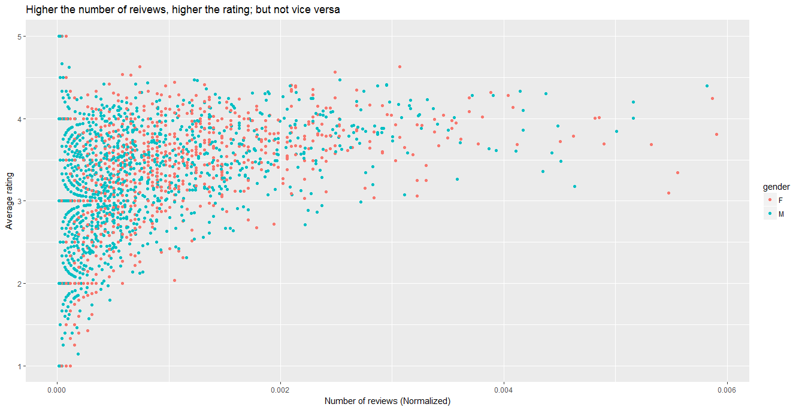

The graph above contains the information related to number of reviews and its average rating, separated by gender. At first glance, the data shows a relatively even spread among males and females and their corresponding rating, with no particular immediate correlation. In addition, the graph identifies an association between number of reviews and high ratings. The more reviews a movie has, the higher its rating. This finding makes logical sense as the more popular movies, the ones more people view, will typically receive more reviews and they will also have a high rating. Although this may be obvious, it is important to note that the inverse is not true. The fewer number of reviews a movie has does not correlate to any specific rating, whether high or low. This is significant as it as it eliminates the idea that the less reviews a movie has, the lower its rating.

-------------------GRAPH OF STATES?

The first connection we wanted to define was whether or not certain states provided higher ratings than others. At first glance, it is clear that California provided the greatest number of reviews in our data set. As a hub for the entertainment industry, it makes sense that California left the most reviews among all states. Although this particular graph does not provide additional trends for other states, we continued our analysis looking at types of genres and the ratings each received.

In general, Film Noir gets the highest ratings, and unknown and fantasy are rated the lowest.

**What groups are most likely to provide higher ratings?**

**Age Groups and Genre Gender and Genre**

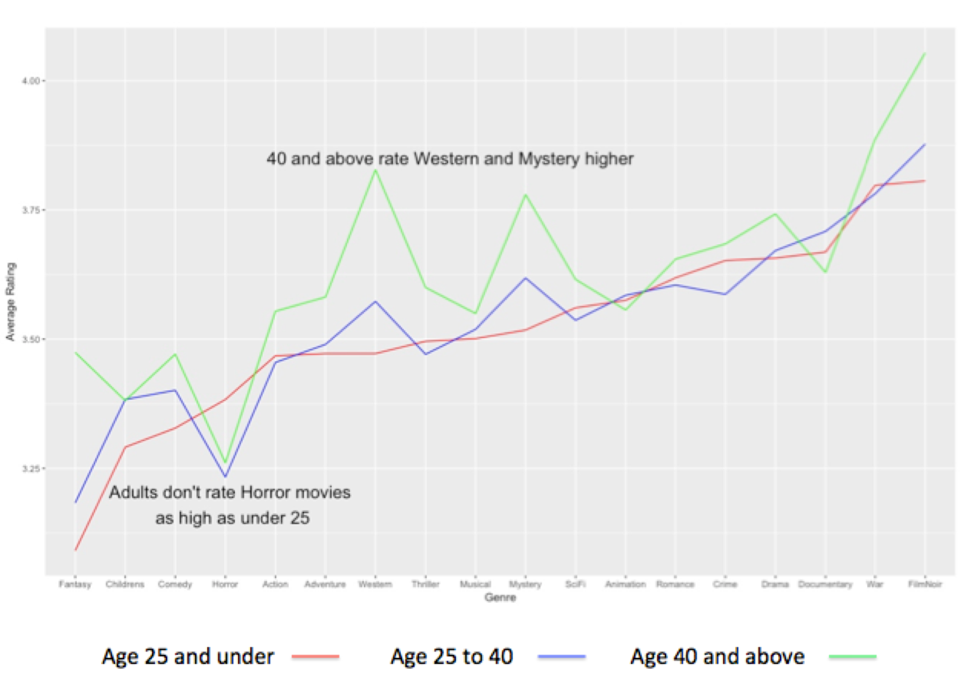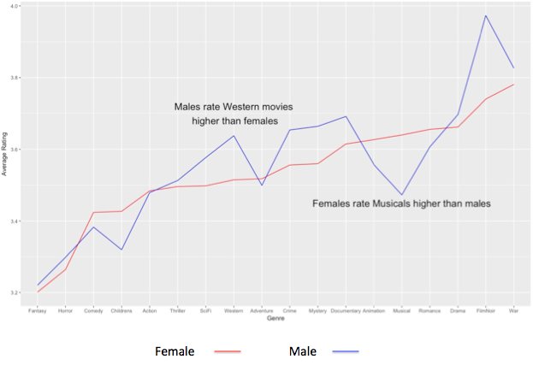

Hypothesizing reviews as a factor of age, we first wanted to identify if there was a relationship between age and ratings, but the correlation coefficient is nearly 0. Thus there is no significant relationship between age and ratings in our data. However, referring to the graph on the left from above (**Age Groups and Genre)**  different age groups rate each genre differently. The oldest group (age 40 and above) tends to give a higher rating for the Fantasy genre compared to the other two groups. The oldest group and the middle group (age 25 to 40) tend to give higher ratings for the Western and Mystery genres, while the youngest group (under 25) favors the Horror genre. Our findings are promising as it separates all the ages into three groups and shows the disparity between review rating and genres amongst each group. This information might be valuable to a client trying to determine what types of genres cater towards specific age groups.

Furthermore, we progressed our analysis to determine if there was a correlation between gender and ratings. The mean ratings for male and females are similar, so there is no apparent correlation between gender and ratings. Considering the genres data provided surprising insight to our age groups, we visualized reviews by gender and genre. From our findings, (**Gender and Genre)**, it is clear that males tend to give higher ratings to Western movies, while females leave higher reviews for Musicals. Once again, genres appears to give us more insight to the data – specifically identifying that there are differences among genders and reviews left for certain genres.

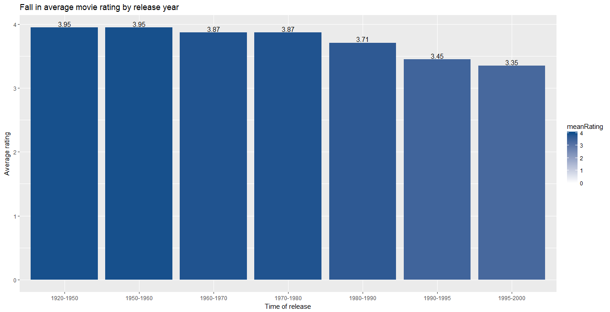

**Appendix 1**: Answers to Questions

1. **Which percentage of each rating was given?**

Rating: Percentage:

1. 6.11%
2. 11.37%
3. 27.145%
4. 34.174%
5. 21.201%
6. **Which reviewers were the top-10 in terms of number of movies reviewed? (Provide the reviewer number and the number of movies reviewed. If there is a tie for 10th place, include all that tied.)**

Reviewer ID: Number of Movies Reviewed:

405 737

655 685

13 636

450 540

276 518

416 493

537 490

303 484

234 480

393 448

1. **Find a 95% confidence interval for the average rating among all reviewers, and a 95% confidence interval for the average rating among the top-10 reviewers. Does there appear to be evidence that the two groups differs?**

Upper and lower limits of 95% confidence interval for all reviewers:

3.559737 and 3.616645

Upper and lower limits of 95% confidence interval for top-10 reviewers:

2.754554 and 3.586818

Does there appear to be evidence that the two groups differ?

Although the confidence intervals slightly overlap, top-10 reviewers has a lower limit than that of all reviewers which can differentiate the two groups. However, it is difficult to make conclusions off this data alone, as the sample size of the top-10 reviewers is clearly lower than that of all reviewers. Further research could be done to answer this question in its entirety. For instance, understanding the standard deviation of just the top-10 reviewers and comparing it to the standard deviation of all reviewers without factoring in sample size could provide more insight amongst the two groups.

All: 0.4452335

Top10 : 0.5817123

95% confidence that the mean of that sample will lie within the upper end and lower range

mean 3.588191for all review

mean 3.170686 for top ten

samples of data set over and over again- calculated corresponding interval – 95% of that data would contain the true mean

1. **Which movies were the top-10 based on of number of times reviewed? (Provide the movie title and the number of times reviewed. If there is a tie for 10th place, include all that tied.)**

Top-10 movies based on number of times reviewed:

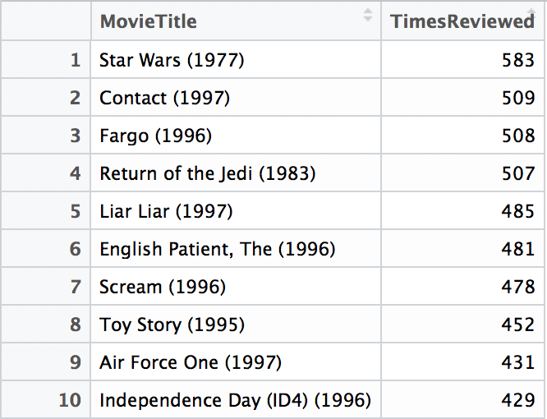

1. **Which genre occurred most often, based on the number of reviews. Which was least often? (Don’t include “unknown” as a genre for this question.)**

Genre that occurred most often based on number of reviews:

Drama : 39895 reviews

Genre that occurred least often based on number of reviews:

Documentary : 758 reviews

1. **What percentage of reviews involved movies classified in at least two genres?**

69.938% of all reviews involved movies classified in at least two genres.

1. **Give a 95% confidence interval for the average rating for male reviewers, and do the same for female reviewers.**

95% confidence interval for the average rating for male reviewers:

3.521309 and 3.537269

95% confidence interval for the average rating for female reviewers:

3.517202 and 3.545813

1. **Which state/territory/Canada/unknown produced the top-5 most reviews?**

State/Territory/Canada/Unknown that produced the top-5 most reviews:

CA, MN, NY, IL, TX

1. **What percentage of movies have exactly 1 review? 2 reviews? 3 reviews? Continue to 20 reviews.**



1. **Which genre had the highest average review, and which had the lowest average review?**

Genre with highest average review: FilmNoir

Genre with lowest average review: Unkown

1. **Repeat the previous question, for reviewers age 30 and under and then for reviewers over 30.**

Highest average review for reviewers age 30 and under: FilmNoir

Lowest average review for reviewers age 30 and under: Fantasy

Highest average review for reviewers over 30: FilmNoir

Lowest average review for reviewers over 30: Unknown